NAME : SHYAM SUNDAR
REG NO : 241801268
EXP NO : 9

1. SELECT last_name, hire_date
FROM employees
WHERE department_id = (SELECT department_id
FROM employees
WHERE last_name = :employee_name)
AND last_name <> :employee_name;
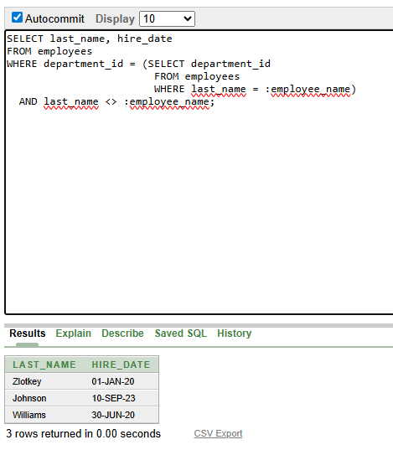

2. SELECT employee_id, last_name, salary FROM employees WHERE salary > (SELECT AVG(salary) FROM employees) ORDER BY salary ASC;
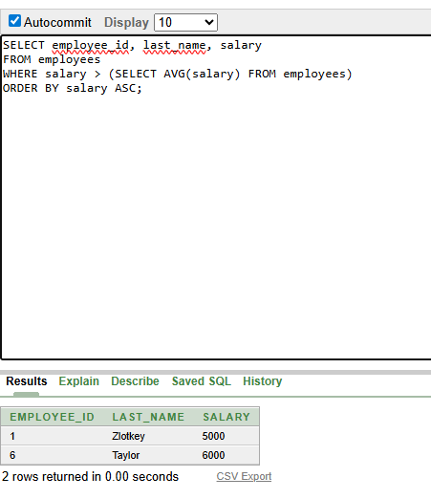

3. SELECT employee_id, last_name
FROM employees
WHERE department_id IN (SELECT department_id
FROM employees
WHERE last_name LIKE '%u%');

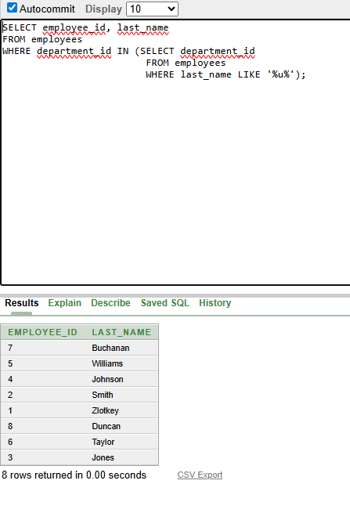

4. SELECT e.last_name, e.department_id
FROM employees e
JOIN departments d ON e.department_id = d.department_id
WHERE d.location_id = 1700;
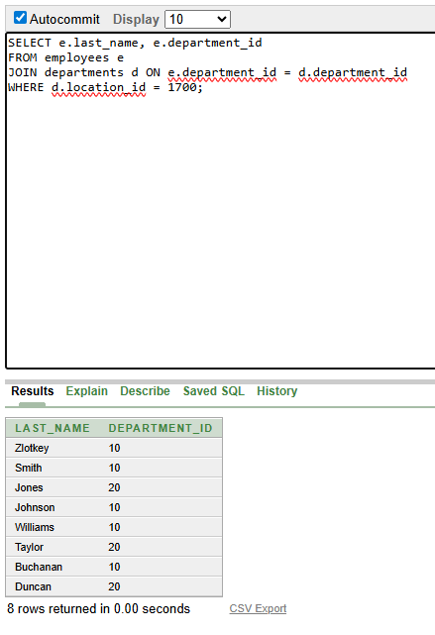

5. SELECT last_name, salary
FROM employees
WHERE manager_id = (SELECT employee_id
FROM employees
WHERE last_name = 'King');

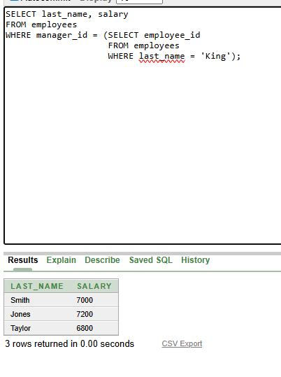

6. SELECT e.department_id, e.last_name
FROM employees e
JOIN departments d ON e.department_id = d.department_id
WHERE d.department_name = 'Executive';
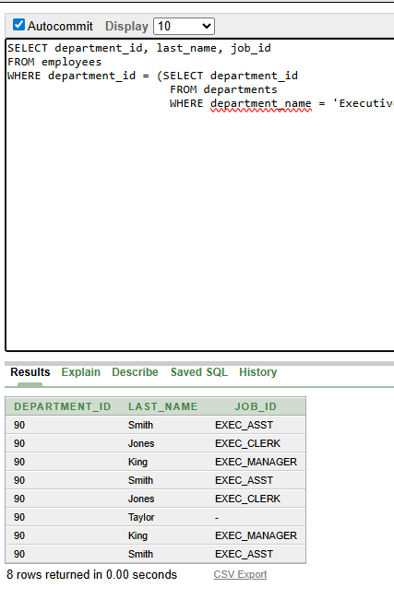

7. SELECT employee_id, last_name, salary
FROM employees
WHERE salary > (
SELECT AVG(salary) FROM employees
)
AND department_id IN (
SELECT department_id
FROM employees
WHERE last_name LIKE '%u%'
);

